Finding information in the Help Center

You can use search to find information in both the knowledge base and the community at the same time. The search results are displayed in two columns, with one column listing the knowledge base results and the other listing the community results.

You can browse the content in one or the other by clicking **Knowledge base** or **Community**. See the following sections for more information.

**Getting around the knowledge base**

The knowledge base consist of categories, sections, and articles. Articles are grouped in sections, and sections are grouped in categories.

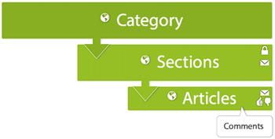

To get around the knowledge base, you can use search or browse categories and sections. If available, use breadcrumbs to go home or to a parent section or category. You may also have links to browse recently viewed articles, related articles, or promoted articles. You can subscribe to sections or articles so that you're notified when somebody creates an article or comments on an article.

**Getting around the community**

The community is where you can post questions or ideas or provide answers. Community posts are associated with topics of discussion.

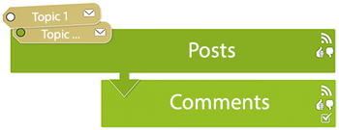

You can use search to get around the community or browse the community discussion topics. You can subscribe to topics or posts so that you're notified when somebody creates a post or comments on a post.

Sorting content in the community

You can view content in community by browsing topics or by showing all the posts in community, regardless of topic. Within topics you can sort posts by newest, recent activity, votes, or comments. Within a post, you can sort comments according to date or votes.

**To show all posts across all topics**

* On the community landing page, click the arrow beside **Community**, then select **Show all posts**.

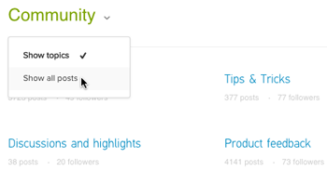

All of the community posts appear in a list, regardless of which topic they are associated with. To show all topics again, select **Show topics**.

**To sort community posts within a topic**

* In a community topic, select one of the following options:
  + **Newest** - (Default) Lists posts in the order they were created, starting with the most recently created
  + **Recent activity** - Lists posts in the order of recent comments, starting with the post that most recently received a comment
  + **Votes** - Lists posts in order by votes, starting with the post that has the most votes
  + **Comments** - Lists posts in order by comments, starting with the post that has the most comments

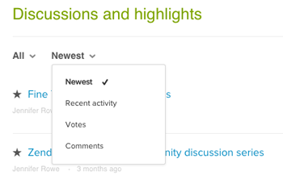

**To sort comments in a topic by date or votes**

* In a community post, select **Dates** or **Votes** to sort the comments by the date the comments were made or by the number of votes the comments have.

Comments appear chronologically by default, with the oldest comment appearing first.

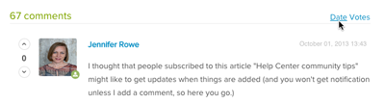

Making posts in the community and viewing your contributions

Before you post, it's always a good idea to run a quick search to see if the question has already been asked and answered in the community.

You can view all your own contributions in one place.

**To make a community post**

1. Click **New post** in the top-right side of any community page.

https://zen-marketing-documentation.s3.amazonaws.com/docs/en/hc_comm_new_post_button.png

1. Enter a **Title** for your post.
2. Enter **Details**, which might be anything, including a question, feature request, or tip.

Use the formatting toolbar as needed.  
The maximum file size for images in posts and comments is 2MB.

1. Select a **Topic** for the post from the drop-down menu, if you want to change the selected topic.
2. Click **Submit**.

**To view all your contributions to the community**

1. Click your profile icon on the upper-right side of any page, and then click **My activities**.
2. Click **Contributions**.

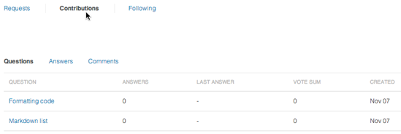

1. Click any link to go to your contribution.

Following content in the KB and community to get updates

You can *follow* sections and articles in the knowledge base and you can follow topics and posts in the community. When you follow content, you are subscribing it, so that you will be notified by email when new articles, posts, or comments are added.

You can stop following content at any time. And you can view all the content you're following in one place and manage your subscriptions there.

**Following content**

In the knowledge base, you can follow section and individual articles. You cannot follow entire categories. In the community, you can follow topics and posts. You will *not* be notified when updates are made to existing articles or posts. You cannot automatically follow all new articles across Help Center. You must follow each section instead.

**To follow a section or topic**

1. Navigate to the section or topic.
2. Click the **Follow**, then choose notifications for only new articles/posts *or* for all new articles/posts and all comments.

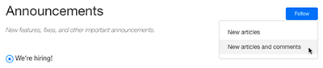

For articles/posts, you will receive email notifications for new articles/posts only in the section or topic. For articles/post and comments, you will receive email notifications for all new articles/posts in the section or post and any new comments.

**To follow an article or post**

1. Navigate to the article or post.
2. Click the **Follow** button.

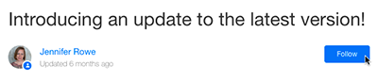

You will receive email notifications for any new comments on the article or post.

**Unfollowing content**

You can stop following content at any time if you no longer want to receive notifications. For sections and topics, you can also modify your subscription if you decide you only want notifications for new articles/posts and not all comments or vice versa.

**To stop following a section or topic**

* In the section or topic, click **Following**, then select **Unfollow**.

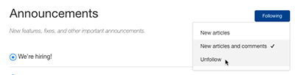

**To stop following an article or post**

* In the article or post, click **Following**.

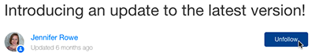

The button changes to Unfollow, indicating that you are no longer following the post; however, you will not receive notifications when the content in the article or post is updated.

**Viewing and managing your subscriptions**

You have access to **My activities**. You can view and modify all your subscriptions in one place. You must be signed in as an end-user to manage your subscriptions.

**To manage your subscriptions**

1. Click your profile icon on the upper-right side of any page, and then click **My activities**.

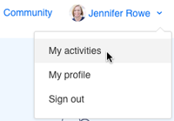

**Note:** You must be signed in as an end-user to see the link.

1. Click **Following**.

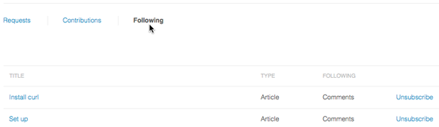

1. Make any changes to your subscriptions.

Unsubscribing removes the subscription from the page.

Sharing links to specific comments

You can easily share a link to a comment on an article or a post to point users to the exact answer or solution.

**To copy a link to a specific comment**

1. Click the options menu beside the comment, then select **Permalink**.

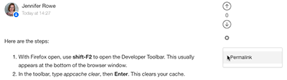

1. Click **Copy**.
2. Paste the link where you want to share it.

Editing the description in your Help Center profile

You can edit your Help Center profile from any Help Center page to change your description.

**To edit your profile**

1. Click your profile icon on the upper-right side of any Help Center page, and then click **My profile** to display your profile.

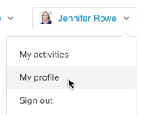

1. In your profile, click **Edit profile**.

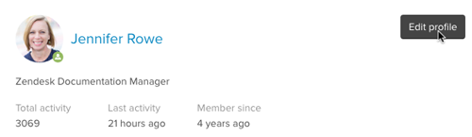

1. Enter text in the **Description** field, then click **Update**.

You cannot edit your name, avatar, phone number, or email address here. That information is set in your user profile, which you can edit by clicking your user profile icon in the top-right corner, then clicking **View profile page**. See [Updating your user profile and password](https://support.zendesk.com/hc/en-us/articles/203690996).

